**Os 1st Internal**

Answer all Questions each Carry 2 marks

* 1. Define operating system

An operating System can be defined as a system software which provides an interface between an user, application and computer

 Examples of Operating System are: **Windows ,Linux ,BOSS ,Android,etc**

* 1. Draw the Process Control Block diagram

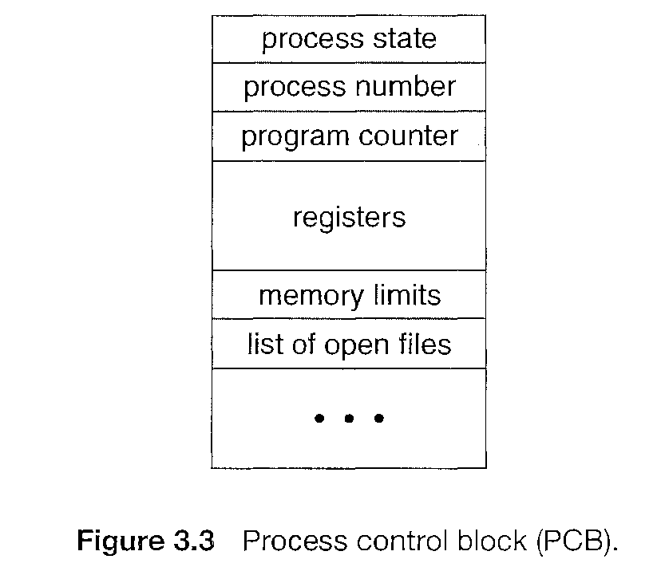

* 1. Mention the different types of scheduling algorithms.

**Scheduling Algorithms in Operating System**

* First-Come, First-Served (FCFS) Scheduling.
* Shortest-Job-Next (SJN) Scheduling.
* Priority Scheduling.
* Shortest Remaining Time.
* Round Robin(RR) Scheduling.
  1. Define virtual machine. Give examples.

A process virtual machine allows a single process to run as an application on a host machine, providing a platform-independent programming environment by masking the information of the underlying hardware or operating system. An example of a process VM is the Java Virtual Machine, which enables any operating system to run Java applications as if they were native to that system.

* 1. Define thread.

A thread is a basic unit of CPU utilization

It comprises of a thread ID, a program counter, a register set and a stack

II. Answer any 4 questions each carry 5 marks

* 1. Explain types of operating system with diagram

Types of Operating Systems

1. Batch Operating System
2. Time-Sharing Operating Systems
3. Distributed Operating System
4. Network Operating System
5. Real-Time Operating System

**1. Batch Operating System**

This type of operating system do not interact with the computer directly. There is an operator which takes similar jobs having same requirement and group them into batches. It is the responsibility of operator to sort the jobs with similar needs.

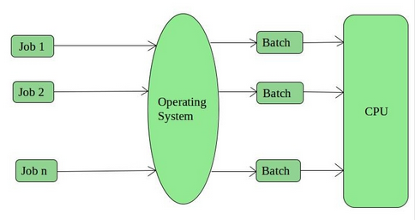

**2. Time-Sharing Operating Systems –**   
Each task is given some time to execute so that all the tasks work smoothly. Each user gets the time of CPU as they use a single system. These systems are also known as Multitasking Systems. The task can be from a single user or different users also. The time that each task gets to execute is called quantum. After this time interval is over OS switches over to the next task.

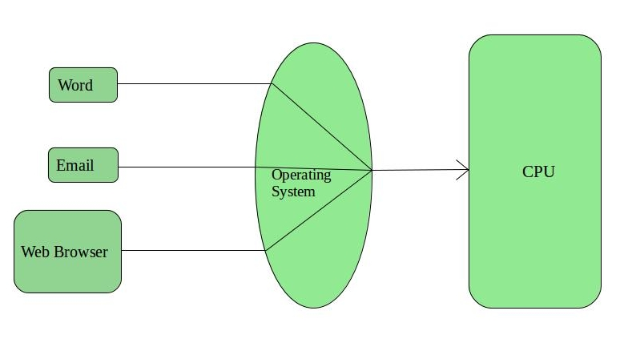

### 3.Distributed Operating System

Distributed systems use many processors located in different machines to provide very fast computation to its users.

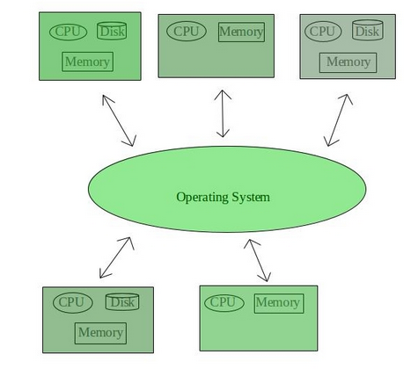

### 4.Network Operating System

Network Operating System runs on a server. It provides the capability to serve to manage data, user, groups, security, application, and other networking functions

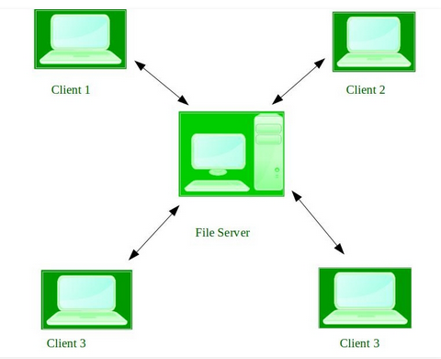

### 5.Real time OS

A real time operating system time interval to process and respond to inputs is very small. Examples: Military Software Systems, Space Software Systems are the Real time OS example.

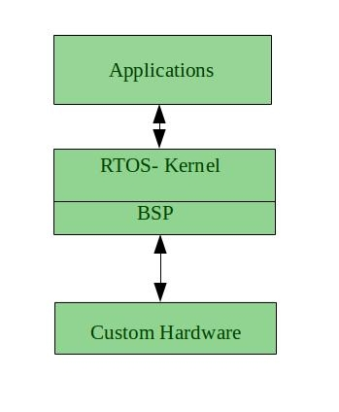

. 7. Explain system calls with diagram

* Process control
  + create process, terminate process
  + end, abort
  + load, execute
  + get process attributes, set process attributes
  + wait for time
  + wait event, signal event
  + allocate and free memory
* File management
  + create file, delete file
  + open, close file
  + read, write, reposition
  + get and set file attributes
* Device management
  + request device, release device
  + read, write, reposition
  + get device attributes, set device attributes
  + logically attach or detach devices
* Information maintenance
  + get time or date, set time or date
  + get system data, set system data
  + get and set process, file, or device attributes
* Communications
  + create, delete communication connection
  + send, receive messages if message passing model to host name or process name
  + From client to server
  + Shared-memory model create and gain access to memory regions
  + transfer status information
  + attach and detach remote devices
  1. Define Process Scheduling and explain the process scheduling-Queuing Diagram.

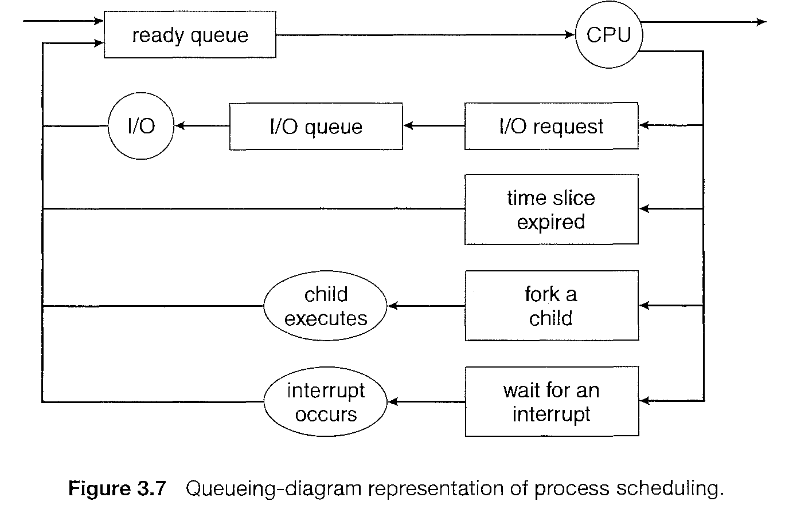

* The act of determining which process is in the **ready** state, and should be moved to the **running** state is known as **Process Scheduling**.
* Job of the scheduler is to keep the CPU occupied to deliver minimum response time for all programs.
* All processes, upon entering into the system, are stored in the **Job Queue**.
* Processes in the Ready state are placed in the **Ready Queue**.
* Processes waiting for a device to become available are placed in **Device Queues**. There are unique device queues available for each I/O device.
* A new process is initially put in the **Ready queue**. It waits in the ready queue until it is selected for execution(or dispatched). Once the process is assigned to the CPU and is executing, one of the following several events can occur:
* The process could issue an I/O request, and then be placed in the **I/O queue**.